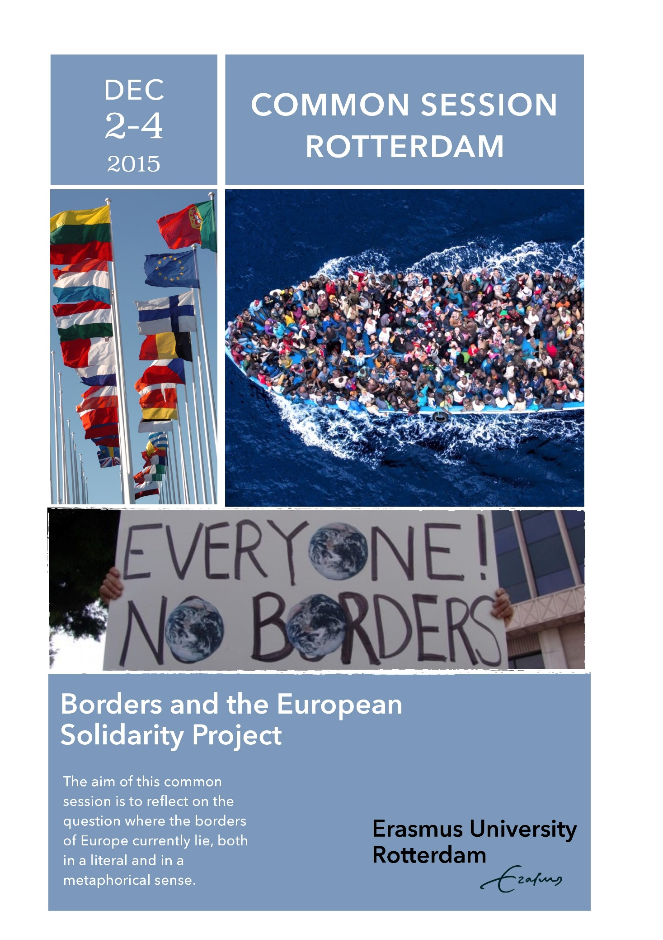
Contents

Preface | Page 2
Contact | Page 5
Morning/afternoon program | Page 6
Evening program | Page 10
How to get to the Erasmus University | Page 12
Erasmus University Campus map | Page 14
Food and drinks on campus | Page 15
Participants | Page 16

Wi-Fi on campus
ERNA-ID: etp72374@eur.nl
Password: Congres1!

University’s address
Erasmus University Rotterdam, Campus Woudestein
Burgemeester Oudlaan 50
3062 PA , Rotterdam
Maps of the campus can be found at: http://www.eur.nl/english/guide/maps/
Preface

Welcome to our wonderful university! Here you can find all the information you need for the Common Study Sessions in Rotterdam. In addition, there are a few important things that need to be explained first:
- On Tuesday the 1st, there is a Welcome Drink in Rotown Rotterdam (Nieuwe Binnenweg 19). We hope to see you there!
- On Wednesday the 2nd you can register from 8.30 till 9.30 hrs. at CT-1 (Theil building), where also the first plenary session will be. If you are arriving on another day or time, please contact someone of the organization team.
- You can sign up for the closing dinner on Friday the 4th! For €15,- you can enjoy a buffet with the other participants at the end of this Common Sessions. You can register at the organization (Veerle or Roos). You have to pay cash when registering. You will get a voucher as proof that you have paid.
- Everyone will get a badge with his/her name and university on it. It is important that these badges are given back on Friday, since they will be used again.
- There are students who will show you where to go during the Common Study Sessions. You can also find a map on page 14. If you cannot find it, please contact someone of the organization team.
- During the Common Study Sessions you can use Wi-Fi on campus. On the first page you can find the ERNA-ID and password you need.

We hope you will enjoy the Common Study Sessions!

Borders and the European Solidarity Project
2-4 December 2015
Erasmus University Rotterdam
The autumn Common Session of 2015 will be organised from 2 to 4 December (with a welcome reception on the 1st and excursions on the 5th) at the Erasmus University Rotterdam on the theme Borders and the European Solidarity Project.
The aim of this common session is to reflect on the question where the borders of Europe currently lie, both in a literal and in a metaphorical sense. Politicians often talk about the ‘European values’, but what are these values and how ‘valuable’ are they in day-to-day politics? Let us try to make these big questions a bit more concrete.
The unification of Europe, with the European Union (EU) as its most manifest embodiment, has its origins in the aftermath of World War II. Economic collaboration was thought to be the best guarantee for an enduring security on the old continent. The Rhineland economic model, with its strong Welfare State and negotiated labour relations between employers and trade unions, symbolised this ‘European Dream’.
Despite their colonial history, Europeans also saw themselves as the protagonists of democratic values and human rights. With this in mind, the scope of the EU was broadened, with the Treaty of Maastricht of 1992, from an economic union to a political body, that was to establish a common European policy on security and justice and home affairs. Hence a ‘Fortress Europe’ was created: ‘internal borders’ within the so-called Schengen Zone were dismantled, but at the same time the ‘external borders’ of the EU were securitised.
With these political aims, and after the fall in 1989 of the ‘Iron Curtain’ between the authoritarian communist East and the socio-liberal capitalist West, the EU became a hotchpotch of countries with very different economic traditions and political histories.
With the securitisation of Europe and the neo-liberal take-over of the 1990s, a new internal conflict was created, that has in the 2000s led to increasing discontent about the EU: both in the founding member-states as well as in the new member-states.
This discontent knows both a Left-wing and a Rightwing line of argumentation. On the one hand, there is the criticism that the EU has become a mere vehicle of a neo-liberal reconstruction of the continent - with the dismantling of the Welfare State and the trade unions as key-examples - whereas on the other hand there is the tendency that, because the EU it has become a hotchpotch of countries that have nothing in common, we should protect the different nation-states again against foreign influences and indeed against the influx of foreigners.
These two lines of argumentation also lie at the heart of two pivotal challenges the EU is facing today: (1) the so-called ‘Free Trade Agreement’ (TTIP) with the USA and (2) the refugee problem that predominantly finds its origins in wars and conflicts in Africa, Central Asia and the Middle East.
The Transatlantic Trade and Investment Partnership (TTIP) is said to be the final deathblow of any remains of the European solidarity project and it is said to jeopardise the democratic legislatory process, by allowing multinational corporations to challenge just any environmental or labour regulation that can possibly endanger their business. It is also in the light of this neo-liberal takeover, that we have to understand the argument (of Greece’s ex Finance Minister Γιάνης Βαρουφάκης) that the ‘Troika’ of the European Commission, the European Central Bank and the International Monetary Fund is actually a criminal organisation, because it humiliates its poorer member-states. The counter-argument of East European countries that they don’t feel obliged to support those - still richer - South European countries who have been squandering during the 1990s and early 2000s, sheds again a different light on the limits of the European solidarity project.
And here is the pivot of the upcoming common session on the borders of Europe: following an economic rationale, a majority of politicians want to put the EU borders wide open for foreign businesses, but these same politicians want to close the EU borders if it concerns the influx of refugees. The business gaze of Europe is quite different from the refugee gaze of it.
On the refugee issue, the European solidarity project is under siege for quite different reasons. First, there is the moral and practical question of how far ‘solidarity’ with people from other countries can actually go if we want to maintain a Welfare State. Second, there is the political question of how solidary EU member-states are with each other. Partly due to a rather strong neo-nationalist electorate in most member states, the EU cannot even come to an agreement on an equal and fair distribution of refugees amongst the member-states – thereby basically leaving the responsibility to protect the EU borders mainly to Greece and Italy.
This very complex, paradoxical and challenging relation of us Europeans to our borders and our values will hopefully result in an interesting autumn 2015 common session.
On behalf of the organising team,

Robby Roks and René van Swaaningen

Organization
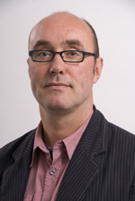
Prof. dr. René van Swaaningen


Drs. Robby Roks

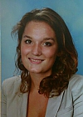
Laura Heijnen (student-assistent)
Contact: +316 5496 4204
heijnen@law.eur.nl

Brent Berghuis
Veerle Bonestroo
Remco Bovens
Gerwin van Brenkelen
Pim de Bruin
Erik Jaspers
Jon Leppers
Babette Segers
Roos Slenters
Rhiannon van Straalen
Maaike Wolters

Morning/afternoon program

Wednesday 2nd December |  |  | Room
9.30 – 10.45 hrs. |  | Plenary sessions | CT-1 (Theil building)
Prof. Suzan Stoter (Dean Erasmus School of Law) |  | Welcome
Prof. René van Swaaningen (ESL Criminology Department) |  | Borders and the European Solidarity Project
Prof. Dario Melossi (BOL) |  | The Criminalization of Migration and the Building of a 'European Union'
11.00 – 12.15 hrs. |  | Parallel sessions | G2-21/G2-26
Refugee crisis (Chair: Keith Hayward KENT):  - Antonia Mischler (HH): The public power of morality. The refugee crisis and its images.  - Valeria Bajana Bilbao (HH): The ‘economic refugee’. On the creation of a deviant other |  |  | G2-21
Othering and marginalisation (Chair: David Porteous MDX):  - Abdessamad Bouabid (EUR): The Moroccans panic: The social construction of 'Moroccans' as folk devils  - Léa Massé (UTR): 'Locked out' on the margin: exploring youth's marginality in French deprived urban neighborhoods |  |  | G2-26
13.15 – 14.45 hrs. | Plenary sessions |  | CT-1 (Theil building)
Richard Staring (EUR) | Borders and Islam
Péter Hack and Dávid Vig (ELTE) | Hungarian reactions to migration
15.00 – 16.45 hrs. | Parallel sessions |  | G3-21/G3-26
(Countering) Moral Panics (Chair: Susanne Krasmann HH)  - Sarah Tosh (CUNY): Immigrant Criminality and Repressive Policy: A Historically-Situated Analysis of an American Moral Panic  - Ann-Sophie Maluck, Nina Niesen & Talea Aselage (HH): Refugees at Hamburg's Cultural Fabric 'Kampnagel' – an Example of Art as Resistance (Artivism)?  - Claudia Czerwinski (EUR): Hypothetical concept of the consequences if internal European borders were to be put up in order to limit peoples movement |  |  | G3-21
Migration and border control (Chair: Olga Petintseva GENT)  - Lynn Musiol (ELTE): Making Space Desirable - Elements of the Border Regime in Hungary  - Andrew Olivares (EUR): Refugee Crisis with a particular emphasis on the Australian policy and how such a policy is not helpful when it comes to the European experience  - Koen Lankhaar (EUR): From Asmara to Amsterdam: Eritrean migration developments explained |  |  | G3-26
Thursday 3rd December |  |  | Room
9.30 – 10.45 hrs. | Plenary sessions |  | CT-1 (Theil building)
Susanne Krasmann and Christine Hentschel (HH) | Being Exposed in Europe
David Brotherton (CUNY) | The performance of Exile: Deportation Hearings a Theaters of Cruelty
11.00 – 12.15 hrs. | Parallel sessions |  | G2-26/G2-46
Migration on the Balkans (Chair: Phil Carney KENT):  - Jing Hiah (EUR): “Corrupt, yet not bad people” Chinese migrants active in the wholesale trade in a post-communist Bucharest: from xiao fei to law and order  - Alexandra Filipescu (UTR): Moldova: breaking away to the European Union |  |  | G2-26
Sexual behavior/prostitution (Chair: Dina Siegel UTR):  - Jutathorn Pravattiyagul (HH/UTR): Thai transgender prostitution in Europe  - Lili Krámer (ELTE): Governing and Treating Sexual Behavior in Hungary 1878-2015 |  |  | G2-46
13.15 – 14.45 hrs. | Plenary sessions |  | CT-1 (Theil building)
Alessandra Arcuri (EUR) | TTIP and Foreign Investors: Are Some Animals More Equals than Others?
Angus Nurse (MDX) | A Common Perspective? European Anti-terrorism Perspectives and the Criminalisation of Free Speech
15.00 – 16.45 hrs. | Parallel sessions |  | G2-26/G3-21
Migration and courts (Chair: Dávid Vig ELTE)  - Caroline Furusho (KENT): Vulnerability, Migration and Regional Human Rights Courts  - Byron Villagómez Moncayo (UTR): The irruption of deportation in the culture of criminal courts in Spain  - Jeffrey Waal (UTR): The Will to Terror: A painted genealogy of ‘State Terror |  |  | G2-26
Automation and notions about ‘crime’ (Chair: René van Swaaningen EUR):  - Benedikt Lehmann (UTR): Towards a post-human subjectivity: financial innovation and the automation of speculation  - Jairo Matallana-Villareal (KENT): Counter-mapping crime: a critical criminology approach  - Wytske van der Wagen (EUR): Deviants without borders? A cyborgian journey through the world of hackers. |  |  | G3-21
Friday 4th December |  |  | Room
9.30 – 10.45 hrs. | Plenary sessions |  | Erasmus Paviljoen
Dina Siegel (UTR) | (No) Sex work in Utrecht: combating crime or combating prostitution?
Olga Petintseva (GENT) | When youth justice and migration intersect. ‘Specialized’ initiatives: building expertise or internal borders?
11.00 – 12.15 hrs. | Parallel sessions |  | G2-21/G2-26
Sexual exploitation (Jenni Ward MDX):  - Aad De Marez (GENT): Sex, the most beautiful thing that money can buy? Critical reflections on the European Honeyball resolution’s response to sexual exploitation and prostitution  - Elena Krsmanovic (UTR): Cultural reflection in images of sexual exploitation: the visual representation of human trafficking in Serbian media |  |  | G2-21
Gangs (Chair: David Brotherton CUNY):  - Robby Roks (EUR): In the h200d: a contemporary ethnography on the embeddedness of crime and identity  - Maria José Cornejo (ELTE): Local Gang Dialogues, Potentials and Risks |  |  | G2-26
13.15 – 14.45 hrs. | Plenary sessions |  | CB-3 (Theil building)
David Redmon (KENT) | Documentary Criminology: Making Media as Interpretation
Galina Sytschjow (HH Thesis presentation)  Jury: Péter Hack (ELTE), Angus Nurse (MDX), and Willem-Jan Verhoeven (EUR)  Chair: René van Swaaningen (EUR) | The Body's Language: Non-Verbal Communication of Shift Working Police Officers
15.00 – 16.45 hrs. | Parallel sessions |  | G2-46/G3-21
Medicines and drugs (Chair: Damián Zaitch UTR):  - Anna Laskai (ELTE): Discussions with doctors: experiences from the field, researching industry-medicine relationships  - Frédérique Bawin (GENT): Self-reported medicinal cannabis use in Flanders  - Jude Oboh (UTR): Cocaine Hoppers. The Nigerian involvement in the Global Cocaine Trade |  |  | G2-46
Law enforcement (Péter Hack ELTE):  - Dennis Pauschinger (HH/KENT): We are trying to dry ice’ Understanding Brazilian Police Work  - Chuan-Fen Chang (HH/ELTE): Justice Inc.: wrongful conviction as an organizational wrongdoing  - Jill van de Rijt and Choukri Farahi (UTR)): Could we extend the borders of self-reliance in Dutch prisons? A different kind of solidarity project |  |  | G3-21

BOL: University of Bologna
CUNY: City University of New York
ELTE: Eötvös Loránd University, Budapest
EUR: Erasmus University Rotterdam
GENT: Ghent University
HH: Hamburg University
KENT: University of Kent
MDX: Middlesex University, London
UTR: Utrecht University

Evening program

Tuesday 1st of December
Welcome Drink
Rotown
Nieuwe Binnenweg 19
Time: from 8 pm (20.00h)
Metro station Eendrachtsplein (line A, B, and C)
Tram station Eendrachtsplein (tram 4 and 7)

Student party
International Student Night ESN
BED Rotterdam
Coolsingel 18
Time: from midnight (00.00h)
Metro station Stadhuis (line D and E)
Tram station Stadhuis (tram 21, 23 and 24)

Wednesday 2nd of December
Over 200 different beers!
Locus International
Oostzeedijk 364
Time: from 8 pm (20.00h)
Metro station Oostplein (line A, B, and C)
Tram station Oostplein (tram 21 and 24)

Student party
Crossroads Rotterdam (student night)
Blender Rotterdam
Schiedamse Vest 91
Time: from midnight (00.00h)
Metro station Beurs (line A, B, C, D, and E)
Tram station Museumpark (tram 7, 8, 20, 23 and 25) or tram station Keizerstraat (tram 21 and 24)

Thursday 3rd of December
Shots
Bar Tender
Coolsingel 83A
Time: from 8 pm (20.00h)
Metro station Stadhuis (line D, and E)
Tram station Stadhuis (tram 21, 23 and 24)

Techno party
BAR
Schiekade 201
Time: from midnight (00.00h)
Metro station Rotterdam Central Station (line D and E)
Tram station Weena or Pompenburg (tram 4, 7, 8, 21, 23 and 24)

Friday 4th of December
Goodbye dinner and party
Soif
Mathenesserdijk 438
Time: from 6 pm (18.00h)
Metro station Delfshaven (line A, B, and C)
Tram station Delfshaven (tram 4 and 8)

How to get to the Erasmus University

The easiest way to get to the Erasmus University Rotterdam (EUR) is by bike or by public transport. You can also take a taxi.

Public transport
The easiest way to travel in Rotterdam is by public transport. If you would like to travel by public transport, you will need the ‘OV-Chipkaart’ (public transport chip card), which can be purchased at:
- Sales devices in stations
- Various newsagents (such as Primera and AKO)
- Various supermarkets
- Some Bruna shops
- A public transport company’s counter
You can find service points with the following link: https://www.ov-chipkaart.nl/customer-service/service-points-finder.htm

More information about the OV-Chipkaart can be found on the website: https://www.ov-chipkaart.nl/home-1.htm

Tram
There are several trams you can take to get to the EUR. While taking the tram, you can also enjoy this beautiful city. You can take tram 7 (direction Woudestein). The last station is the Erasmus University Rotterdam and it stops in front of the campus. You can also take tram 21 and 24 (direction De Esch). Tram 21 and 24 are faster than tram 7, but these trams do not stop in front of the campus. You have to go to tram station Woudestein or Oude Plantage. From there you have to walk for ± 5 minutes to the campus.

Metro
The metro is the fastest way to travel, especially in the city centre. With your OV-Chipkaart you can go everywhere. There are five different lines which you can take. The closest metro station to the Erasmus University Rotterdam is Kralingse Zoom (lines A, B and C; if you are coming from the city centre, you have to take direction Binnenhof, Nesselande or De Terp). Then you have to walk for ± 10 minutes to get to the campus. If you would like to go shopping, then you should go to metro station Beurs. You can take the train at metro station Blaak, Rotterdam Centraal, Schiedam Centrum and Alexander.

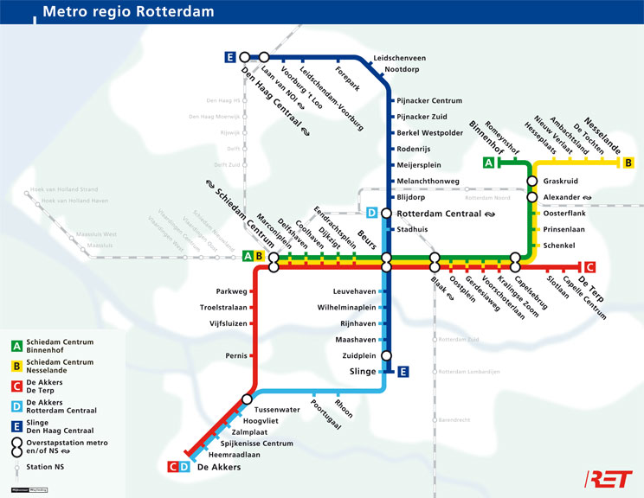

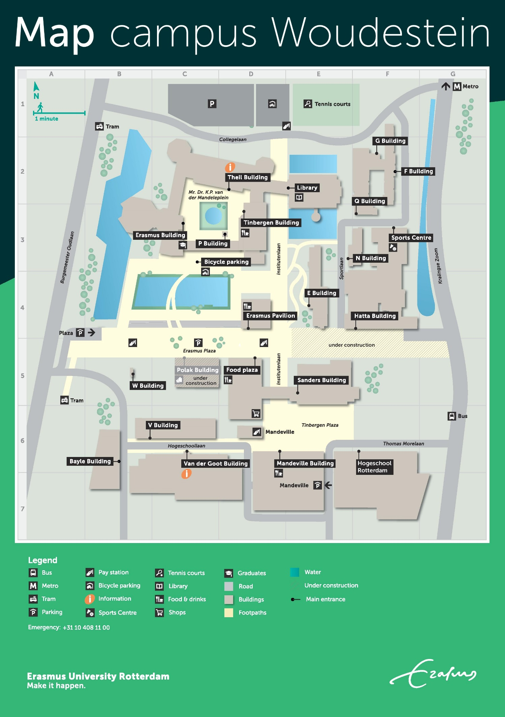

Food and drinks on campus

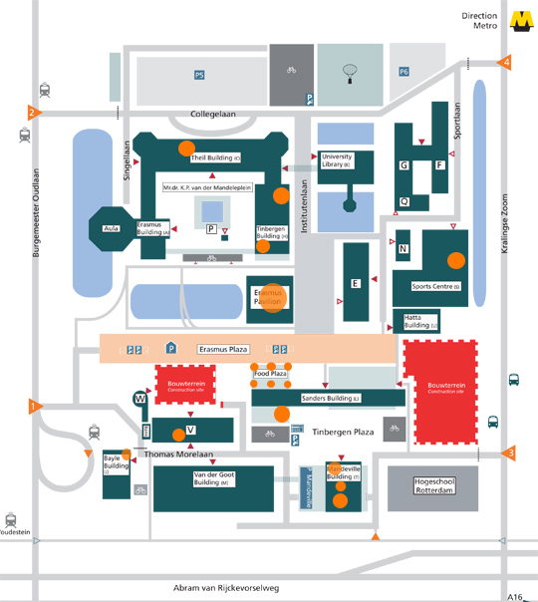

You can get food and drinks at the orange dots

Participants Common Sessions Rotterdam 2015

Erasmus University Rotterdam
Staff Members | John Blad  Abdessamad Bouabid  Jing Hiah  Erik Jaspers  Tom de Leeuw  Robby Roks  Richard Staring  René van Swaaningen  Samira Valkeman  Wytske van der Wagen
Students | Jeritza Abdala  Milou Andriessen  Brent Berghuis  Veerle Bonestroo  Remco Bovens  Gerwin van Brenkelen  Pim de Bruin  Claudia Czerwinski  Bram Emmen  Kim Geurtjens  Laura Heijnen  Josephine van der Hoeven  Hanneke Kooloos  Sanne Korhorn  Rianne Kramer  Koen Lankhaar  Jon Leppers  Elya Massij (post-graduate)  Klaas Mullenberg  Andrew Olivares  Marc Pangalila  Babette Segers  Roos Slenters  Rhiannon van Straalen  Maaike Wolters
City University of New York – John Jay College of Criminal Justice
Staff Member | David Brotherton
Student | Sarah Tosh
Middlesex University London
Staff Members | Angus Nurse  David Porteous  Anna Reiners  Jenni Ward
Students | Danielle Blake  Chandra Edwards  Marjam Gjanba  Daniel Gyollai  Mary Alice Hughes  Tina Kern  Irtiza Sheikh (post-graduate)  Hollie Smith
University of Hamburg
Staff Members | Christine Hentschel  Susanne Krasmann
DCGC’s | Chuan-Fen Chen  Dennis Pauschinger  Jutathorn Pravattiyagul
Students | Laila Abdul-Rahman  Johannes Aschermann  Talea Aselage  Valeria Bajana Bilbao  Nils Bienzeisler  Silina Breitewischer  Caroline Claus  Eva Teresa Dietz  Adrian Gerling  Julia Gessert  Anna Franke  Franziska Franz  Heike Holz  Greta Kowol  Sandra Linneck  Ann-Sophie Maluck  Antonia Mischler  Nina Niesen  Niobe Osius  Max Querbach  Fiona Reinke  Ida Roscher  Ann-Sophie Schäfer  Sarah Schaible  Magdalena Schierl  Galina Sytschjow
Ghent University
Staff Members | Tom Decorte  Olga Petintseva
PhD | Frédérique Bawin
Students | Nadine Drolshagen  Michelle van Impe  Aad De Marez  Michiel Praet
University of Kent
Staff Members | Phil Carney  Marian Duggan  Chris Hale  Keith Hayward  Roger Matthews  David Redmon
PhD’s/DCGC’s | Daniel Beizsley  Jorge Castañeda Ochoa  Caroline Furusho  Brendan Hough  Jairo Matallana-Villareal  Stefano Mazzilli-Daechsel  Deirdre Ruane  Vitor Stegemann Dieter
Student | Madeline Hughes
Utrecht University
Staff Members | Veronika Nagy  Brenda Oude Breuil  Dina Siegel  Daan van Uhm  Roos de Wildt  Damián Zaitch
PhD’s | Elena Krsmanovic  Elina Kurtovic  Benedikt Lehmann  Clara Musto  Jude Oboh  Julia Rushchenko  Byron Villagómez Moncayo
Students | Chantal van Beek  Stan de Beus  Hilde Boersma  Lieke Brouwer  Marloes de Bruin  Karin Brummelhuis  Walesi Cakaunivere  Rutger Clijnk  Kata Debrei  Philip Drenth  Marilena Drymioti  Jodie Edwards  Choukri Farahi  Alexandra Filipescu  Marit de Haan  Nikki de Haas  Iris den Hartog  Wim van Herk  Josephine Hofstee  Aline Jabbari  Shelley Jürgensen  Eva Kiemeney  Layla Kramer  Anouk de Lange  Panagiotis Markopoulos  Léa Massé  Timothy Merten  Wobke Mulder  Lisa Overmars  Dominique Pars  Jill van de Rijt  Phie van Rompu  Sanne Rooijakkers  Sarah Rust  Emma Smits  Lisa van der Spek  Lene Swetzer  Micheal Taylor  Laura van Tilborg  Tom van Tulden  Karen Vermeer  Jeffrey Waal  Ola Weber
Eötvös Loránd University (ELTE)
Staff Members | Péter Hack  Dávid Vig
DCGC’s | Maria José Cornejo  Anna Laskai
Students | Lili Krámer  Lynn Musiol

